

Semester One Examination, 2018

Question/Answer booklet

MATHEMATICS SPECIALIST
UNIT 3

Section One:

Calculator-free

Your Name_________________________________________

Your Teacher’s Name_________________________________

Time allowed for this section
Reading time before commencing work: five minutes
Working time: fifty minutes

Materials required/recommended for this section
To be provided by the supervisor
This Question/Answer booklet
Formula sheet

To be provided by the candidate
Standard items: pens (blue/black preferred), pencils (including coloured), sharpener, correction fluid/tape, eraser, ruler, highlighters

Special items: nil

Important note to candidates
No other items may be taken into the examination room. It is your responsibility to ensure that you do not have any nauthorized material. If you have any nauthorized material with you, hand it to the supervisor before reading any further.

Question | Mark | Question | Mark
1 |  | 5
2 |  | 6
3 |  | 7
4 |  | 8

Structure of this paper

Section | Number of questions available | Number of questions to be answered | Working time (minutes) | Marks available | Percentage of examination
Section One:  Calculator-free | 8 | 8 | 50 | 50 | 35
Section Two:  Calculator-assumed | 13 | 13 | 100 | 95 | 65
 |  |  |  | Total | 100

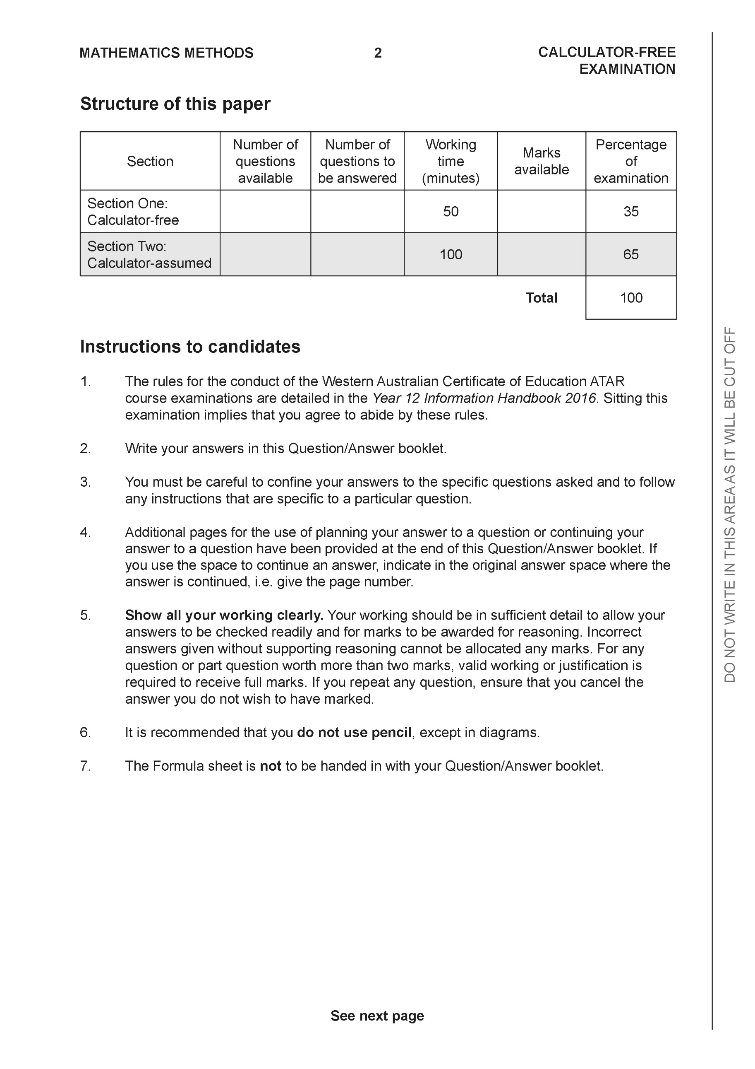

Section One: Calculator-free (50 Marks)

This section has eight (8) questions. Answer all questions. Write your answers in the spaces provided.

Spare pages are included at the end of this booklet. They can be used for planning your responses and/or as additional space if required to continue an answer.
● Planning: If you use the spare pages for planning, indicate this clearly at the top of the page.
● Continuing an answer: If you need to use the space to continue an answer, indicate in the original answer space where the answer is continued, i.e. give the page number. Fill in the number of the question that you are continuing to answer at the top of the page.

Working time: 50 minutes.

Question 1 (8 marks)

Consider the polynomial where
(a) Determine the roots of and label them (2 marks)

(b) Determine (3 marks)

(c) Determine (3 marks)

Question 2 (7 marks)

Let where are real numbers.
(a) Show that (2 marks)

(b) The expression can be written in the form , determine expressions for the real constants in terms of . (3 marks)

(c) Given that the and , determine the . (2 marks)

Question 3 (7 marks)

Consider the following functions .

(a) State the natural domain and range of . (2 marks)

(b) State the natural domain and range of (3 marks)

(c) Does exist over the natural domain of ? Explain. (2 marks)

Question 4 (7 marks)

Consider the function , which is plotted on the axes below.
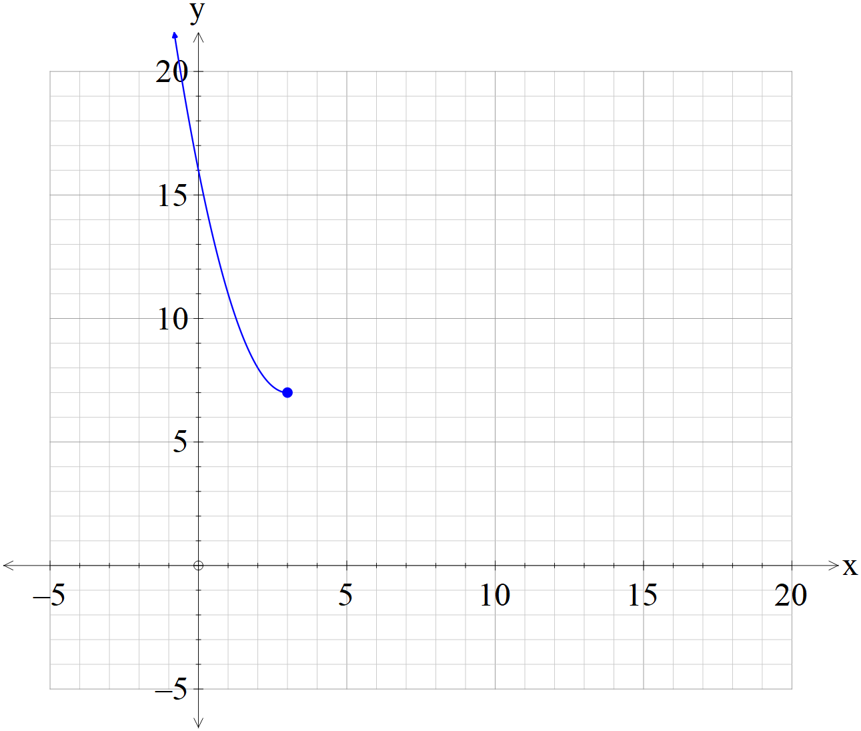
(a) Sketch the inverse function on the axes above. (3 marks)
(b) Determine the rule for the inverse function and state the domain and range.
(4 marks)

Question 5 (5 marks)

Consider the graph of which is graphed below.
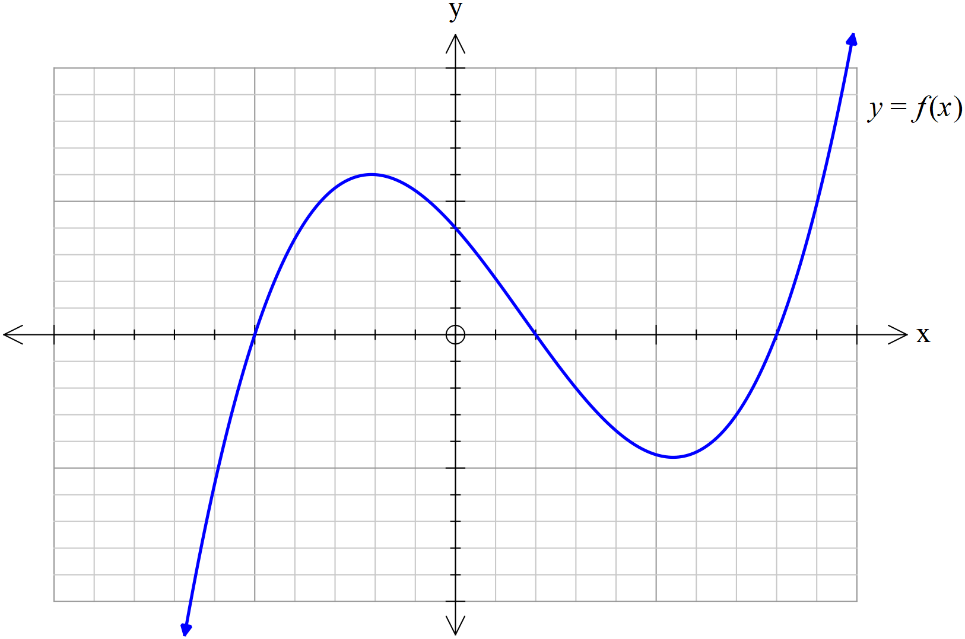

(a) On the axes below, sketch (2 marks)
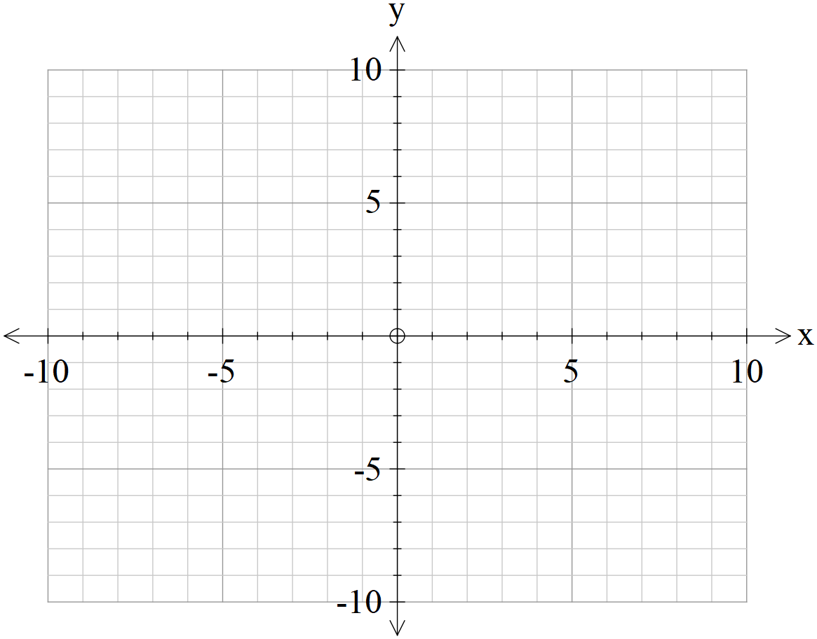

(b) On the axes below, sketch (3 marks)



Question 6 (6 marks)
Sketch the graph of on the axes below.



Question 7 (5 marks)
A triangular prism OACB is shown below with O as the origin and points A, B & C have respective position vectors Point P lies on the line in the ratio .

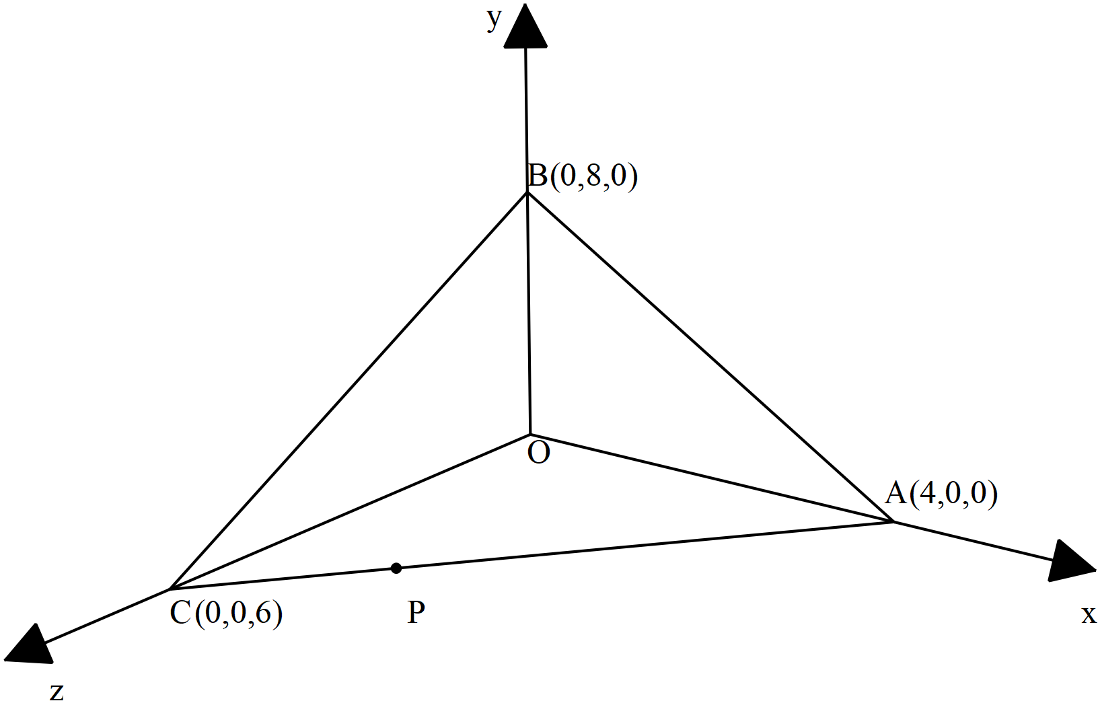
(a) Determine the vector equation of the line that passes through points
( 2 marks)

(b) Determine the cartesian equation of the plane that contains points .
( 3 marks)

Question 8 (5 marks)

Consider a circle in the complex plane where the centre is given by and a radius of 5 units. Let be a point on this circle where with and

(a) Determine in exact cartesian form . ( 3 marks)

(b) Sketch this circle and point P in the complex plane below showing all major features.
( 2 marks)

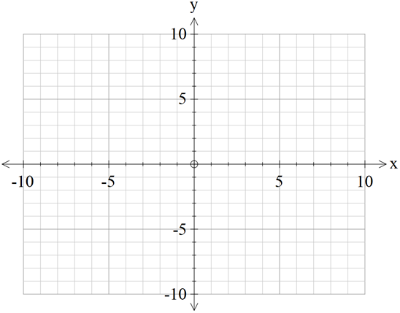
Re(z)
Im(z)
Additional working space
Question number:

Additional working space
Question number:

Additional working space
Question number:

Additional working space
Question number:

